Structural Equation Modeling Output

**Syntax**

**Model 1**

#latent variables

swb =~ sptot + hopewill + hopeway

mh =~ psstot + bsidep + bsianx

ese =~ esewalk + esebike + eseweek

#regressions

ese ~ swb + mh

#covariances

swb ~~ mh

**Model 2**#latent variables

swb =~ sptot + hopewill + hopeway

mh =~ psstot + bsidep + bsianx

ese =~ esewalk + esebike + eseweek

#regressions

ese ~ swb + mh

#covariances

swb ~~ mh

#residual covariances

bsianx ~~ esewalk

**Output**

| **Model fit** | | | | | | | | | | | | | | | | | | | |
| --- | --- | --- | --- | --- | --- | --- | --- | --- | --- | --- | --- | --- | --- | --- | --- | --- | --- | --- | --- |
|  | | | | | | | | **Baseline test** | | | | | | **Difference test** | | | | | |
|  | | **AIC** | | **BIC** | | **n** | | **χ²** | | **df** | | **p** | | **Δχ²** | | **Δdf** | | **p** | |
| Model 2 |  | 1465.435 |  | 1507.822 |  | 29 |  | 25.925 |  | 23 |  | 0.304 |  |  |  |  |  |  |  |
| Model 1 |  | 1470.679 |  | 1511.698 |  | 29 |  | 33.169 |  | 24 |  | 0.101 |  | 7.244 |  | 1 |  | 0.007 |  |
|  | | | | | | | | | | | | | | | | | | | |

| **Fit indices** | | | | | |
| --- | --- | --- | --- | --- | --- |
| **Index** | | **Model 1** | | **Model 2** | |
| Comparative Fit Index (CFI) |  | 0.948 |  | 0.984 |  |
| T-size CFI |  | 0.744 |  | 0.817 |  |
| Tucker-Lewis Index (TLI) |  | 0.923 |  | 0.974 |  |
| Bentler-Bonett Non-normed Fit Index (NNFI) |  | 0.923 |  | 0.974 |  |
| Bentler-Bonett Normed Fit Index (NFI) |  | 0.845 |  | 0.879 |  |
| Parsimony Normed Fit Index (PNFI) |  | 0.563 |  | 0.561 |  |
| Bollen's Relative Fit Index (RFI) |  | 0.767 |  | 0.810 |  |
| Bollen's Incremental Fit Index (IFI) |  | 0.952 |  | 0.985 |  |
| Relative Noncentrality Index (RNI) |  | 0.948 |  | 0.984 |  |
|  | | | | | |
| *Note.*  T-size CFI is computed for *α = 0.05* | | | | | |
| *Note.*  The T-size equivalents of the conventional CFI cut-off values (poor < 0.90 < fair < 0.95 < close) are **poor < 0.551 < fair < 0.649 < close** for model: Model 2 | | | | | |
| *Note.*  The T-size equivalents of the conventional CFI cut-off values (poor < 0.90 < fair < 0.95 < close) are **poor < 0.554 < fair < 0.651 < close** for model: Model 1 | | | | | |

| **Information criteria** | | | | | |
| --- | --- | --- | --- | --- | --- |
|  | | **Model 1** | | **Model 2** | |
| Log-likelihood |  | -705.340 |  | -701.718 |  |
| Number of free parameters |  | 30.000 |  | 31.000 |  |
| Akaike (AIC) |  | 1470.679 |  | 1465.435 |  |
| Bayesian (BIC) |  | 1511.698 |  | 1507.822 |  |
| Sample-size adjusted Bayesian (SSABIC) |  | 1418.357 |  | 1411.369 |  |
|  | | | | | |

| **Other fit measures** | | | | | |
| --- | --- | --- | --- | --- | --- |
| **Metric** | | **Model 1** | | **Model 2** | |
| Root mean square error of approximation (RMSEA) |  | 0.115 |  | 0.066 |  |
| RMSEA 90% CI lower bound |  | 0.000 |  | 0.000 |  |
| RMSEA 90% CI upper bound |  | 0.202 |  | 0.172 |  |
| RMSEA p-value |  | 0.156 |  | 0.394 |  |
| T-size RMSEA |  | 0.206 |  | 0.175 |  |
| Standardized root mean square residual (SRMR) |  | 0.086 |  | 0.083 |  |
| Hoelter's critical N (α = .05) |  | 32.838 |  | 40.344 |  |
| Hoelter's critical N (α = .01) |  | 38.578 |  | 47.577 |  |
| Goodness of fit index (GFI) |  | 0.995 |  | 0.996 |  |
| McDonald fit index (MFI) |  | 0.854 |  | 0.951 |  |
| Expected cross validation index (ECVI) |  | 3.213 |  | 3.032 |  |
|  | | | | | |
| *Note.*  T-size RMSEA is computed for *α = 0.05* | | | | | |
| *Note.*  The T-size equivalents of the conventional RMSEA cut-off values (close < 0.05 < fair < 0.08 < poor) are **close < 0.164 < fair < 0.18 < poor** for model: Model 1 | | | | | |
| *Note.*  The T-size equivalents of the conventional RMSEA cut-off values (close < 0.05 < fair < 0.08 < poor) are **close < 0.166 < fair < 0.181 < poor** for model: Model 2 | | | | | |

| **R-Squared** | | | | | |
| --- | --- | --- | --- | --- | --- |
|  | | **R²** | | | |
|  | | **Model 1** | | **Model 2** | |
| sptot |  | 0.645 |  | 0.644 |  |
| hopewill |  | 0.983 |  | 0.985 |  |
| hopeway |  | 0.264 |  | 0.264 |  |
| psstot |  | 0.561 |  | 0.546 |  |
| bsidep |  | 0.923 |  | 0.946 |  |
| bsianx |  | 0.781 |  | 0.732 |  |
| esewalk |  | 0.848 |  | 0.873 |  |
| esebike |  | 0.417 |  | 0.457 |  |
| eseweek |  | 0.834 |  | 0.799 |  |
| ese |  | 0.191 |  | 0.144 |  |
|  | | | | | |

**Model 1**

| **Factor Loadings** | | | | | | | | | | | | | | | | | |
| --- | --- | --- | --- | --- | --- | --- | --- | --- | --- | --- | --- | --- | --- | --- | --- | --- | --- |
|  | | | | | | | | | | | | | | **95% Confidence Interval** | | | |
| **Latent** | | **Indicator** | |  | | **Estimate** | | **Std. Error** | | **z-value** | | **p** | | **Lower** | | **Upper** | |
| ese |  | esewalk |  |  |  | 6.980 |  | 1.193 |  | 5.852 |  | < .001 |  | 4.642 |  | 9.317 |  |
|  |  | esebike |  |  |  | 4.650 |  | 1.248 |  | 3.728 |  | < .001 |  | 2.205 |  | 7.095 |  |
|  |  | eseweek |  |  |  | 4.976 |  | 0.858 |  | 5.801 |  | < .001 |  | 3.295 |  | 6.658 |  |
| mh |  | psstot |  |  |  | 6.207 |  | 1.331 |  | 4.662 |  | < .001 |  | 3.597 |  | 8.816 |  |
|  |  | bsidep |  |  |  | 4.610 |  | 0.670 |  | 6.879 |  | < .001 |  | 3.296 |  | 5.923 |  |
|  |  | bsianx |  |  |  | 3.179 |  | 0.532 |  | 5.973 |  | < .001 |  | 2.136 |  | 4.223 |  |
| swb |  | sptot |  |  |  | 8.421 |  | 1.640 |  | 5.134 |  | < .001 |  | 5.207 |  | 11.636 |  |
|  |  | hopewill |  |  |  | 1.803 |  | 0.252 |  | 7.154 |  | < .001 |  | 1.309 |  | 2.296 |  |
|  |  | hopeway |  |  |  | 1.076 |  | 0.367 |  | 2.931 |  | 0.003 |  | 0.357 |  | 1.795 |  |
|  | | | | | | | | | | | | | | | | | |

| **Regression coefficients** | | | | | | | | | | | | | | | | | |
| --- | --- | --- | --- | --- | --- | --- | --- | --- | --- | --- | --- | --- | --- | --- | --- | --- | --- |
|  | | | | | | | | | | | | | | **95% Confidence Interval** | | | |
| **Predictor** | | **Outcome** | |  | | **Estimate** | | **Std. Error** | | **z-value** | | **p** | | **Lower** | | **Upper** | |
| swb |  | ese |  |  |  | 0.729 |  | 0.446 |  | 1.635 |  | 0.102 |  | -0.145 |  | 1.602 |  |
| mh |  | ese |  |  |  | 0.341 |  | 0.426 |  | 0.800 |  | 0.424 |  | -0.494 |  | 1.176 |  |
|  | | | | | | | | | | | | | | | | | |

| **Factor covariances** | | | | | | | | | | | | | | | |
| --- | --- | --- | --- | --- | --- | --- | --- | --- | --- | --- | --- | --- | --- | --- | --- |
|  | | | | | | | | | | | | **95% Confidence Interval** | | | |
| **Variables** | |  | | **Estimate** | | **Std. Error** | | **z-value** | | **p** | | **Lower** | | **Upper** | |
| swb - mh |  |  |  | -0.827 |  | 0.074 |  | -11.106 |  | < .001 |  | -0.973 |  | -0.681 |  |
|  | | | | | | | | | | | | | | | |

| **Residual variances** | | | | | | | | | | | | | | | |
| --- | --- | --- | --- | --- | --- | --- | --- | --- | --- | --- | --- | --- | --- | --- | --- |
|  | | | | | | | | | | | | **95% Confidence Interval** | | | |
| **Variable** | |  | | **Estimate** | | **Std. Error** | | **z-value** | | **p** | | **Lower** | | **Upper** | |
| sptot |  |  |  | 38.973 |  | 11.826 |  | 3.296 |  | < .001 |  | 15.794 |  | 62.151 |  |
| hopewill |  |  |  | 0.056 |  | 0.268 |  | 0.210 |  | 0.834 |  | -0.470 |  | 0.582 |  |
| hopeway |  |  |  | 3.232 |  | 0.858 |  | 3.768 |  | < .001 |  | 1.551 |  | 4.914 |  |
| psstot |  |  |  | 30.126 |  | 8.558 |  | 3.520 |  | < .001 |  | 13.353 |  | 46.900 |  |
| bsidep |  |  |  | 1.778 |  | 1.428 |  | 1.245 |  | 0.213 |  | -1.021 |  | 4.577 |  |
| bsianx |  |  |  | 2.838 |  | 1.003 |  | 2.830 |  | 0.005 |  | 0.873 |  | 4.804 |  |
| esewalk |  |  |  | 10.830 |  | 7.948 |  | 1.363 |  | 0.173 |  | -4.747 |  | 26.407 |  |
| esebike |  |  |  | 37.378 |  | 10.486 |  | 3.564 |  | < .001 |  | 16.825 |  | 57.931 |  |
| eseweek |  |  |  | 6.095 |  | 4.100 |  | 1.487 |  | 0.137 |  | -1.940 |  | 14.131 |  |
|  | | | | | | | | | | | | | | | |

**Model 1**

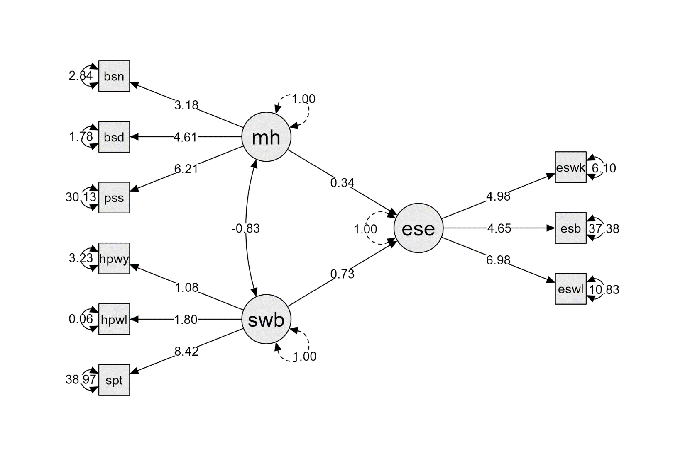

**Model 2**

| **Factor Loadings** | | | | | | | | | | | | | | | | | |
| --- | --- | --- | --- | --- | --- | --- | --- | --- | --- | --- | --- | --- | --- | --- | --- | --- | --- |
|  | | | | | | | | | | | | | | **95% Confidence Interval** | | | |
| **Latent** | | **Indicator** | |  | | **Estimate** | | **Std. Error** | | **z-value** | | **p** | | **Lower** | | **Upper** | |
| ese |  | esewalk |  |  |  | 7.311 |  | 1.122 |  | 6.515 |  | < .001 |  | 5.112 |  | 9.510 |  |
|  |  | esebike |  |  |  | 5.011 |  | 1.247 |  | 4.017 |  | < .001 |  | 2.566 |  | 7.456 |  |
|  |  | eseweek |  |  |  | 5.013 |  | 0.858 |  | 5.840 |  | < .001 |  | 3.331 |  | 6.696 |  |
| mh |  | psstot |  |  |  | 6.123 |  | 1.334 |  | 4.590 |  | < .001 |  | 3.509 |  | 8.738 |  |
|  |  | bsidep |  |  |  | 4.668 |  | 0.662 |  | 7.047 |  | < .001 |  | 3.369 |  | 5.966 |  |
|  |  | bsianx |  |  |  | 2.928 |  | 0.492 |  | 5.948 |  | < .001 |  | 1.963 |  | 3.893 |  |
| swb |  | sptot |  |  |  | 8.410 |  | 1.643 |  | 5.120 |  | < .001 |  | 5.191 |  | 11.630 |  |
|  |  | hopewill |  |  |  | 1.805 |  | 0.252 |  | 7.152 |  | < .001 |  | 1.310 |  | 2.299 |  |
|  |  | hopeway |  |  |  | 1.076 |  | 0.367 |  | 2.931 |  | 0.003 |  | 0.356 |  | 1.795 |  |
|  | | | | | | | | | | | | | | | | | |

| **Regression coefficients** | | | | | | | | | | | | | | | | | |
| --- | --- | --- | --- | --- | --- | --- | --- | --- | --- | --- | --- | --- | --- | --- | --- | --- | --- |
|  | | | | | | | | | | | | | | **95% Confidence Interval** | | | |
| **Predictor** | | **Outcome** | |  | | **Estimate** | | **Std. Error** | | **z-value** | | **p** | | **Lower** | | **Upper** | |
| swb |  | ese |  |  |  | 0.533 |  | 0.390 |  | 1.366 |  | 0.172 |  | -0.232 |  | 1.297 |  |
| mh |  | ese |  |  |  | 0.164 |  | 0.382 |  | 0.429 |  | 0.668 |  | -0.584 |  | 0.912 |  |
|  | | | | | | | | | | | | | | | | | |

| **Factor covariances** | | | | | | | | | | | | | | | |
| --- | --- | --- | --- | --- | --- | --- | --- | --- | --- | --- | --- | --- | --- | --- | --- |
|  | | | | | | | | | | | | **95% Confidence Interval** | | | |
| **Variables** | |  | | **Estimate** | | **Std. Error** | | **z-value** | | **p** | | **Lower** | | **Upper** | |
| swb - mh |  |  |  | -0.820 |  | 0.076 |  | -10.845 |  | < .001 |  | -0.968 |  | -0.672 |  |
|  | | | | | | | | | | | | | | | |

| **Residual variances** | | | | | | | | | | | | | | | |
| --- | --- | --- | --- | --- | --- | --- | --- | --- | --- | --- | --- | --- | --- | --- | --- |
|  | | | | | | | | | | | | **95% Confidence Interval** | | | |
| **Variable** | |  | | **Estimate** | | **Std. Error** | | **z-value** | | **p** | | **Lower** | | **Upper** | |
| sptot |  |  |  | 39.155 |  | 11.928 |  | 3.283 |  | 0.001 |  | 15.777 |  | 62.532 |  |
| hopewill |  |  |  | 0.049 |  | 0.276 |  | 0.178 |  | 0.859 |  | -0.491 |  | 0.589 |  |
| hopeway |  |  |  | 3.233 |  | 0.858 |  | 3.769 |  | < .001 |  | 1.552 |  | 4.914 |  |
| psstot |  |  |  | 31.154 |  | 8.704 |  | 3.579 |  | < .001 |  | 14.094 |  | 48.213 |  |
| bsidep |  |  |  | 1.239 |  | 1.372 |  | 0.903 |  | 0.367 |  | -1.451 |  | 3.929 |  |
| bsianx |  |  |  | 3.143 |  | 1.009 |  | 3.114 |  | 0.002 |  | 1.165 |  | 5.122 |  |
| esewalk |  |  |  | 9.100 |  | 7.625 |  | 1.193 |  | 0.233 |  | -5.845 |  | 24.045 |  |
| esebike |  |  |  | 34.802 |  | 9.729 |  | 3.577 |  | < .001 |  | 15.734 |  | 53.871 |  |
| eseweek |  |  |  | 7.372 |  | 3.731 |  | 1.976 |  | 0.048 |  | 0.059 |  | 14.684 |  |
|  | | | | | | | | | | | | | | | |

| **Residual covariances** | | | | | | | | | | | | | | | |
| --- | --- | --- | --- | --- | --- | --- | --- | --- | --- | --- | --- | --- | --- | --- | --- |
|  | | | | | | | | | | | | **95% Confidence Interval** | | | |
| **Variables** | |  | | **Estimate** | | **Std. Error** | | **z-value** | | **p** | | **Lower** | | **Upper** | |
| bsianx - esewalk |  |  |  | 4.093 |  | 1.724 |  | 2.374 |  | 0.018 |  | 0.714 |  | 7.472 |  |
|  | | | | | | | | | | | | | | | |

#### Model 2

